OLYMPIC VENUE AUDIO SYSTEMS

Live Document always lives [here](https://docs.google.com/document/d/1pXArwdrKA_SSGy-Synzo44OmVXvV6fFvyCrFSwNAagM/edithttps://docs.google.com/document/d/1pXArwdrKA_SSGy-Synzo44OmVXvV6fFvyCrFSwNAagM/edit)

**OVERVIEW**

For the MILAN CORTINA 2024 Olympic Games we have revamped the Audio Systems that will be deployed at all Olympic Venues. The goal of this change is to provide a more streamlined / modern workflow, along with uniformity, and flexible resources to adapt to evolving production needs. These new systems are Dante based and are equipped to integrate with any truck or flypack regardless of signal types needed for a console and intercom. There are 10 systems which are intended to be deployed individually but the resources from each system can be used freely with any other, with no configuration changes and no need to worry about addressing conflicts. These 10 systems are a stand alone network island and should not be integrated with any other existing Dante network, if resources needed to be added to the system there are spare addresses available that will work with the Audio Systems.

Each system includes the following -

COMPOUND KIT

BOOTH KIT

AUDIO KITS (BETWEEN 1 and 3 kits depending on the system)

All connectivity is based on fiber connections between the core network switches in the COMPOUND KIT and the switches in the BOOTH KIT as well as the AUDIO KITS (AK). The COMPOUND KIT and The BOOTH KIT have both a Primary and Secondary switch while the Audio Kits only have a single Primary Switch. The COMPOUND KIT connects directly to the Main Mix Console OR RP-1 via MADI and Intercom either directly over Dante or through Madi using a [Ferrofish](https://www.ferrofish.com/portfolio/a32pro-dante-converter-multimode/) as a conversion tool.

Studio Technologies Model 234 announce consoles, Model 381 Mic / IFB beltpacks, and Model 374 PL bodypacks are being used as the end devices at all locations. Since every device across all 10 systems has a unique name and IP address these devices can be plugged into any switch on any system and will become available on the Dante Network. The model 381 and model 374 units have a single ethernet port which **MUST** only ever be plugged into **PRIMARY SWITCHES** or the Dante Network will present errors. The model 234 announce consoles are dual NIC devices and have both a primary and secondary ethernet port so they can run in a fully redundant and protected mode in case of network or switch failure. On the model 234 announce consoles the primary ethernet port must only ever connect to a **PRIMARY SWITCH** port and the secondary ethernet port must only ever connect to a **SECONDARY SWITCH** port. If a 234 announce console is being connected using an AUDIO KIT only the primary ethernet port needs to be connected, operation of the device is un-effected but it will only be running on the primary Dante Network.

Included in the COMPOUND KIT is a rack mounted PC which is loaded with all software necessary to manage the devices in the systems. Software installed on the COMPOUND KIT PC include Dante Controller for audio crosspoint mapping, ST controller for management of all Studio Technologies Devices, RemoteFish for management of the Ferrofish unit, LANCE ADX for management of the Lance 120 units which can be deployed for voice over rooms or other “oh by the way” asks. The compound PC units can be controlled locally through an included keyboard, mouse, and screen OR remotely over the NBC network using Microsoft Remote Desktop.

All systems have been tested and supplied with a baseline configuration along with specific documentation for each venue set up. It is expected that production requests will change and the set ups will need to remain flexible. The remainder of this document will provide an in-depth overview of the intended system design and its capabilities.

**NETWORK FIBER CONNECTIVITY**

As noted above the Venue Audio Systems is a Dante based system where the network switches are deployed in a star topology - the BOOTH KIT and AUDIO KITS should connect back to the core switches in the COMPOUND KIT. The fiber ports in each switch break out to an ST fiber connector panel in each kit. Using the ST fiber breakout panels, connect the **PRIMARY SWITCHES** to the **PRIMARY SWITCHES** and the **SECONDARY SWITCHES** to the **SECONDARY SWITCHES** at each location. It is imperative that we do not cross any primary and secondary ports as this will cause errors on the network and defeat the purpose of the redundant networks. In both this document and physically on the kits, **BLUE** denotes a primary switch connection and **RED** denotes a secondary switch connection.

-*See the below image for a simple network topology of a COMPOUND KIT, BOOTH KIT, and 3 AUDIO KITS-*

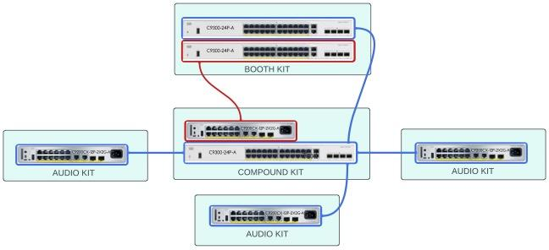

The fibers needed to connect each kit back to the compound is as follows

COMPOUND KIT <> BOOTH KIT -6 FIBER STRANDS

1 - PRIMARY SWITCH MAIN FIBER

2 - PRIMARY SWITCH BACK UP FIBER

3 - SECONDARY SWITCH MAIN FIBER

4 - SECONDARY SWITCH BACK UP FIBER

5 - SESCOM AUDIO TO BOOTH *(analog back-up detailed elsewhere in this document)*

6 - SESCOM AUDIO FROM BOOTH *(analog back-up detailed elsewhere in this document)*

COMPOUND KIT <> AUDIO KITS -2 FIBER STRANDS PER KIT

1 - PRIMARY SWITCH MAIN FIBER

2 - PRIMARY SWITCH BACK UP FIBER

Best practice is to connect all fiber strands on the COMPOUND KIT end, but only connect the main fibers on the BOOTH KIT and AUDIO KIT ends. In a failed fiber scenario, the back-up fiber should be connected and used in place of the failed main fiber path. Since the system carries all essential audio redundantly no on air audio will be lost on this transition. If both the main and back-up fibers are connected, the system will operate as designed, pushing all connectivity through the Main fiber port and the Back Up port will be in stand-by mode. This config can be verified visually by checking the connectivity lights on the uplink ports - the active port will be green and the port in standby will have an amber light - if set up in this mode and the fiber fails, there will be a 30 second loss of audio while the traffic renegotiates to the back-up port

*The drawing below shows the standard connection workflow when using two AUDIO KITS - Also note the purple and orange connections between BOOTH KIT and the COMPOUND KIT which are being used to carry back up audio over fiber outside of the Dante networks. Although this audio travels on fiber it flows completely outside of the network infrastructure.*

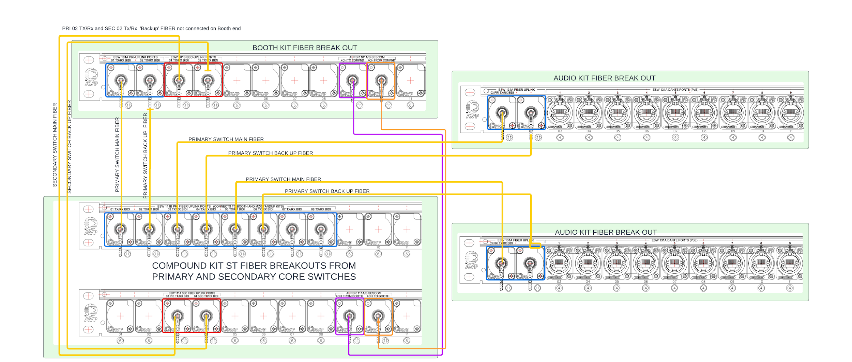

**CONNECTION TO FLYPACK OR MOBILE UNIT**

While the Audio Systems are very flexible they are intended to be connected in one of two ways depending on which MILAN CORTINA 2024 venues they are deployed at.

Integration with a Mobile Unit

If being used with a truck or large scale mobile unit, the Audio System is intended to be integrated to both the audio console and intercom bi-directionally over a Fiber Madi connection. In this configuration the Ferrofish will be used to convert all incoming Dante signals to Madi and the outgoing Madi signals to Dante. Please be aware that if a mobile unit has an existing Dante Network it is not intended to be used with the Audio Systems as all devices exist on a statically defined isolated network. If there is a need to ever use truck based audio equipment - Omneo cards - Calrec Cards etc… spare device addresses can be supplied on a case by case basis, but in basic operation all integration with the Audio Systems is meant to be through bi-directional MADI streams.

In this mode the outgoing MADI signal from the truck to the Ferrofish will be clocked to the truck’s black burst or other valid time generator and the Ferrofish clock will need to be set to the incoming Madi signal in the Ferrofish clocking menu. In Dante Controller the Ferrofish should be set as the Clock Leader and *SYNC TO EXTERNAL* must be enabled on the Ferrofish in the Dante Controller clocking menu. This set-up effectively syncs the whole system to the truck’s clock and must be configured this way to avoid audio artifacts on the incoming and outgoing audio signals.

The truck’s intercom is the source of all the IFB and PL signals in this set up - IFB outputs need to be added on to the same outgoing MADI stream as all other signals to the Ferrofish. Additionally 8 ‘4 wire signals’ need to be created over the MADI channels to make use of the Studio Tech Mix Engine In the Compound Kit that drives the Studio Tech Model 374 belt packs. The PL creation will need 8 output ports of the truck’s intercom routed to the outgoing Madi Stream and then 8 channels of the incoming MADI stream will be routed back to those same 8 intercom port to create the digital 4 wires which can then be added to PL’s in AZ edit as normal.

*See the image below for very basic signal flow of IFB and PL integration* 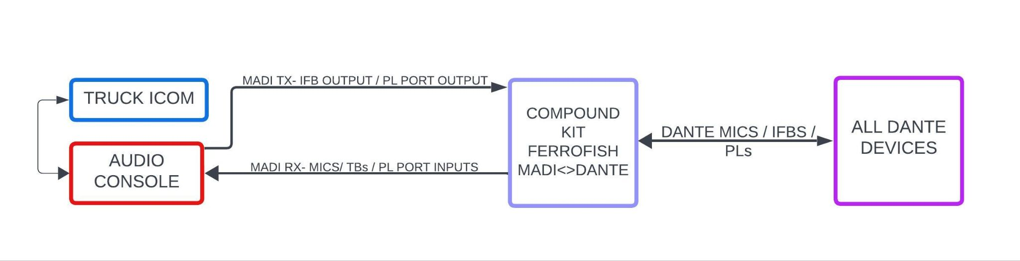

The MADI connection on the patch panel of the compound kit can be connected to the trucks MADI using ST fiber strands. While there are two fiber connections for MADI RX and TX on the Ferrofish unit only one Receive (RX) connector can be in use at a time - however the device will transmit (TX) on both ST connector outputs redundantly, so it may be beneficial in some setups to run a secondary fiber connection to receive a redundant MADI stream in the truck as a back up. The clocking for the entire Audio System will be set based on the RX MADI port on the Ferrofish as detailed above. The clocking menu of the Ferrofish can be accessed through the front control panel or through the Remotefish app on the Compound PC and should be set to MADI 1.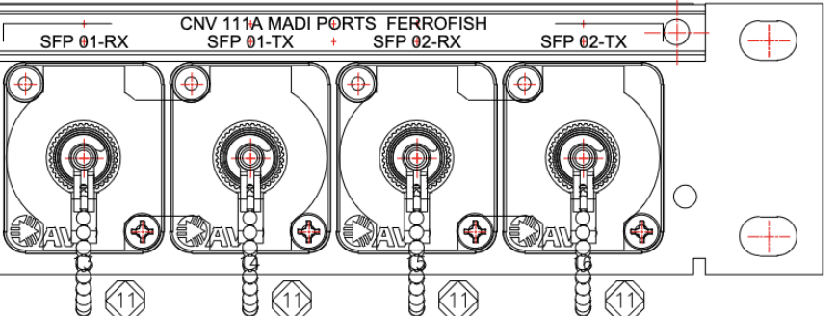

The image on the following page shows an example layout of the signal traffic, the bi directional MADI between the Ferrofish and the mobile unit. Based on the perception of the mobile unit, on the incoming MADI signals there are microphone and talkback signals from the Studio Tech Model 234 and 381 devices along with XLR inputs from the model 5418 which is an XLR to Dante device. At the bottom of the list are the 8 channels incoming from the Studio Tech Mix Engine- which allows the use of a single port to drive multiple channels. On the outgoing MADI signals there are stereo IFBs and 8 intercom ports that should be routed to the Studio Tech Mix Engine. In addition any generic source that needs to be fed to the 5418 XLR converters and any other device should be routed across this MADI as all traffic to the Audio System from the truck needs to flow here.

| **AUDIO SYSTEM <> MADI** | | | | | | | | |
| --- | --- | --- | --- | --- | --- | --- | --- | --- |
| **DANTE INPUTS > FERROFISH > MADI INPUTS** | | | |  | **MADI OUTPUTS > FERROFISH > END DEVICES** | | | |
| **PORT** | **TRAFFIC** | **NOTE 1** | **NOTE 2** |  | **PORT** | **TRAFFIC** | **NOTE 1** | **NOTE 2** |
| FERO 01 | MIC 234_01 |  |  |  | FERO 01 | IFB INT 234-01 | *PORT ###* |  |
| FERO 02 | TB1 234_01 |  |  |  | FERO 02 | IFB NON 234-01 | *PORT ###* |  |
| FERO 03 | TB2 234_01 |  |  |  | FERO 03 | IFB INT 234-02 | *PORT ###* |  |
| FERO 04 | MIC 234_02 |  |  |  | FERO 04 | IFB NON 234-02 | *PORT ###* |  |
| FERO 05 | TB1 234_02 |  |  |  | FERO 05 | IFB INT 234-03 | *PORT ###* |  |
| FERO 06 | TB2 234_02 |  |  |  | FERO 06 | IFB NON 234-03 | *PORT ###* |  |
| FERO 07 | MIC 234_03 |  |  |  | FERO 07 | IFB INT 234-04 | *PORT ###* |  |
| FERO 08 | TB1 234_03 |  |  |  | FERO 08 | IFB NON 234-04 | *PORT ###* |  |
| FERO 09 | TB2 234_03 |  |  |  | FERO 09 | IFB INT SDPLY-05 | *PORT ###* |  |
| FERO 10 | MIC 234_04 |  |  |  | FERO 10 | IFB NON SDPLY-05 | *PORT ###* |  |
| FERO 11 | TB1 234_04 |  |  |  | FERO 11 | IFB INT SDPLY-06 | *PORT ###* |  |
| FERO 12 | TB2 234_04 |  |  |  | FERO 12 | IFB NON SDPLY-06 | *PORT ###* |  |
| FERO 13 | MIC SDPLY-234-05 |  |  |  | FERO 13 | IFB INT SDPLY-07 | *PORT ###* |  |
| FERO 14 | TB1 SDPLY-234-05 |  |  |  | FERO 14 | IFB NON SDPLY-07 | *PORT ###* |  |
| FERO 15 | TB2 SDPLY-234-05 |  |  |  | FERO 15 | IFB INT SDPLY-08 | *PORT ###* |  |
| FERO 16 | MIC SDPLY-234-06 |  |  |  | FERO 16 | IFB NON SDPLY-08 | *PORT ###* |  |
| FERO 17 | TB1 SDPLY-234-06 |  |  |  | FERO 17 | IFB INT 381-01 |  |  |
| FERO 18 | TB2 SDPLY-234-06 |  |  |  | FERO 18 | IFB NON 381-01 |  |  |
| FERO 19 | MIC SDPLY-234-07 |  |  |  | FERO 19 | IFB INT 381-02 |  |  |
| FERO 20 | TB1 SDPLY-234-07 |  |  |  | FERO 20 | IFB NON 381-02 |  |  |
| FERO 21 | TB2 SDPLY-234-07 |  |  |  | FERO 21 | IFB INT 381-03 |  |  |
| FERO 22 | MIC SDPLY-234-08 |  |  |  | FERO 22 | IFB NON 381-03 |  |  |
| FERO 23 | TB1 SDPLY-234-08 |  |  |  | FERO 23 | IFB INT 381-04 |  |  |
| FERO 24 | TB2 SDPLY-234-08 |  |  |  | FERO 24 | IFB NON 381-04 |  |  |
| FERO 25 | MIC S02-381-01 |  |  |  | FERO 25 | IFB INT 381-05 |  |  |
| FERO 26 | TB S02-381-01 |  |  |  | FERO 26 | IFB NON 381-05 |  |  |
| FERO 27 | MIC S02-381-02 |  |  |  | FERO 27 | IFB INT 381-06 |  |  |
| FERO 28 | TB S02-381-02 |  |  |  | FERO 28 | IFB NON 381-06 |  |  |
| FERO 29 | MIC S02-381-03 |  |  |  | FERO 29 | IFB INT 381-07 |  |  |
| FERO 30 | TB S02-381-03 |  |  |  | FERO 30 | IFB NON 381-07 |  |  |
| FERO 31 | MIC S02-381-04 |  |  |  | FERO 31 | IFB INT 381-08 |  |  |
| FERO 32 | TB S02-381-04 |  |  |  | FERO 32 | IFB NON 381-08 |  |  |
| FERO 33 | MIC S02-381-05 |  |  |  | FERO 33 | IFB INT 381-09 |  |  |
| FERO 34 | TB S02-381-05 |  |  |  | FERO 34 | IFB NON 381-09 |  |  |
| FERO 35 | MIC S02-381-06 |  |  |  | FERO 35 | IFB INT 381-10 |  |  |
| FERO 36 | TB S02-381-06 |  |  |  | FERO 36 | IFB NON 381-10 |  |  |
| FERO 37 | MIC S02-381-07 |  |  |  | FERO 37 | 5418-BTH-01 |  |  |
| FERO 38 | TB S02-381-07 |  |  |  | FERO 38 | 5418-BTH-02 |  |  |
| FERO 39 | MIC S02-381-08 |  |  |  | FERO 39 | 5418-BTH-03 |  |  |
| FERO 40 | TB S02-381-08 |  |  |  | FERO 40 | 5418-BTH-04 |  |  |
| FERO 41 | MIC S02-381-09 |  |  |  | FERO 41 | 5418-AK1-01 |  |  |
| FERO 42 | TB S02-381-09 |  |  |  | FERO 42 | 5418-AK1-02 |  |  |
| FERO 43 | MIC S02-381-10 |  |  |  | FERO 43 | 5418-AK1-03 |  |  |
| FERO 44 | TB S02-381-10 |  |  |  | FERO 44 | 5418-AK1-04 |  |  |
| FERO 45 | BTH5418-01 |  |  |  | FERO 45 | 5418-AK2-01 |  |  |
| FERO 46 | BTH5418-02 |  |  |  | FERO 46 | 5418-AK2-02 |  |  |
| FERO 47 | BTH5418-03 |  |  |  | FERO 47 | 5418-AK2-03 |  |  |
| FERO 48 | BTH5418-04 |  |  |  | FERO 48 | 5418-AK2-04 |  |  |
| FERO 49 | AK1 5418-01 |  |  |  | FERO 49 | 5418-AK3-01 |  |  |
| FERO 50 | AK1 5418-02 |  |  |  | FERO 50 | 5418-AK3-02 |  |  |
| FERO 51 | AK1 5418-03 |  |  |  | FERO 51 | 5418-AK3-03 |  |  |
| FERO 52 | AK1 5418-04 |  |  |  | FERO 52 | 5418-AK3-04 |  |  |
| FERO 53 | AK2 5418-01 |  |  |  | FERO 53 | PROD HOT |  | FROM CALREC |
| FERO 54 | AK2 5418-02 |  |  |  | FERO 54 | DIR HOT |  | FROM CALREC |
| FERO 55 | AK3 5418-01 |  |  |  | FERO 55 | AD HOT MIC |  | FROM CALREC |
| FERO 56 | LANCE MIC |  |  |  | FERO 56 |  |  |  |
| FERO 57 | S02-MIXE-PL1 | CAMS CH 8 | PORT ### |  | FERO 57 | S02-MIXE-PL1 | CAMS CH 8 | PORT ### |
| FERO 58 | S02-MIXE-PL2 | STAGE CH 8 | PORT ### |  | FERO 58 | S02-MIXE-PL2 | STAGE CH 8 | PORT ### |
| FERO 59 | S02-MIXE-PL3 | A2 CH 8 | PORT ### |  | FERO 59 | S02-MIXE-PL3 | A2 CH 8 | PORT ### |
| FERO 60 | S02-MIXE-PL4 | STAT CH 8 | PORT ### |  | FERO 60 | S02-MIXE-PL4 | STAT CH 8 | PORT ### |
| FERO 61 | S02-MIXE-PL5 | SPOT CH 8 | PORT ### |  | FERO 61 | S02-MIXE-PL5 | SPOT CH 8 | PORT ### |
| FERO 62 | S02-MIXE-PL6 | PROD CH 8 | PORT ### |  | FERO 62 | S02-MIXE-PL6 | PROD CH 8 | PORT ### |
| FERO 63 | S02-MIXE-PL7 | OBTW CH 8 | PORT ### |  | FERO 63 | S02-MIXE-PL7 | OBTW CH 8 | PORT ### |
| FERO 64 | S02-MIXE-PL8 | PROGRAM CH 8 | PORT ### |  | FERO 64 | S02-MIXE-PL8 | PROGRAM CH 8 | PORT ### |

Integration with a Flypack and Calrec RP-1

During the MILAN CORTINA 2024 Olympic Games some of the Audio Systems will be used with RP-1 and Odin Intercom based flypack systems which have already been statically addressed to work with the Dante Network. Any of the Audio Systems can integrate quickly and directly with the RP-1 and Odin - this process works very similarly to the connection process of a Mobile Unit but in this configuration the Ferrofish MADI/DANTE converter is bypassed in favor of direct connection. In the compound kit, there are two white ethernet cables labeled with Blue and Red e-tape which are intended to plug into the Primary and Secondary ports of the Dante Card in the Calrec RP-1’s “C” port.

The Odin Intercom also has Primary and Secondary “OMNEO” ports which will connect directly to our Primary and and Secondary switches. For the purposes of basic operation OMNEO **IS** Dante so don’t let the labeling and different naming be confusing.

It is imperative that both the Primary and Secondary Dante ports are connected on these devices - without these connections the redundancy of the system will not work as intended if the critical systems don’t have the secondary network running.

The direct connection of the Calrec RP-1 and Odin Intercom let signals flow directly from the RP-1 console and the intercom to the Dante end devices. For example - The Microphone from a Model 234 announce console is routed directly to the Calrec RP-1 and landed on a fader - This source is then mixed with other necessary audio signals and sent to the Odin intercom using an RP1 auxiliary output patched to a Dante output. In the Odin Intercom a stereo IFB has been created, where the same signals leaving the RP-1 Aux have been set to the input of the IFB - The output of the IFB is then routed directly to the Dante RX ports of the Model 234 announce console.

In the same way the IFBs are set directly to the end devices from the intercom, the ports married to PLs are routed directly to and from the Studio Tech Mix Engine - no converter is necessary in this workflow.

*See the image below for very basic signal flow of IFB and PL integration in this connection model*

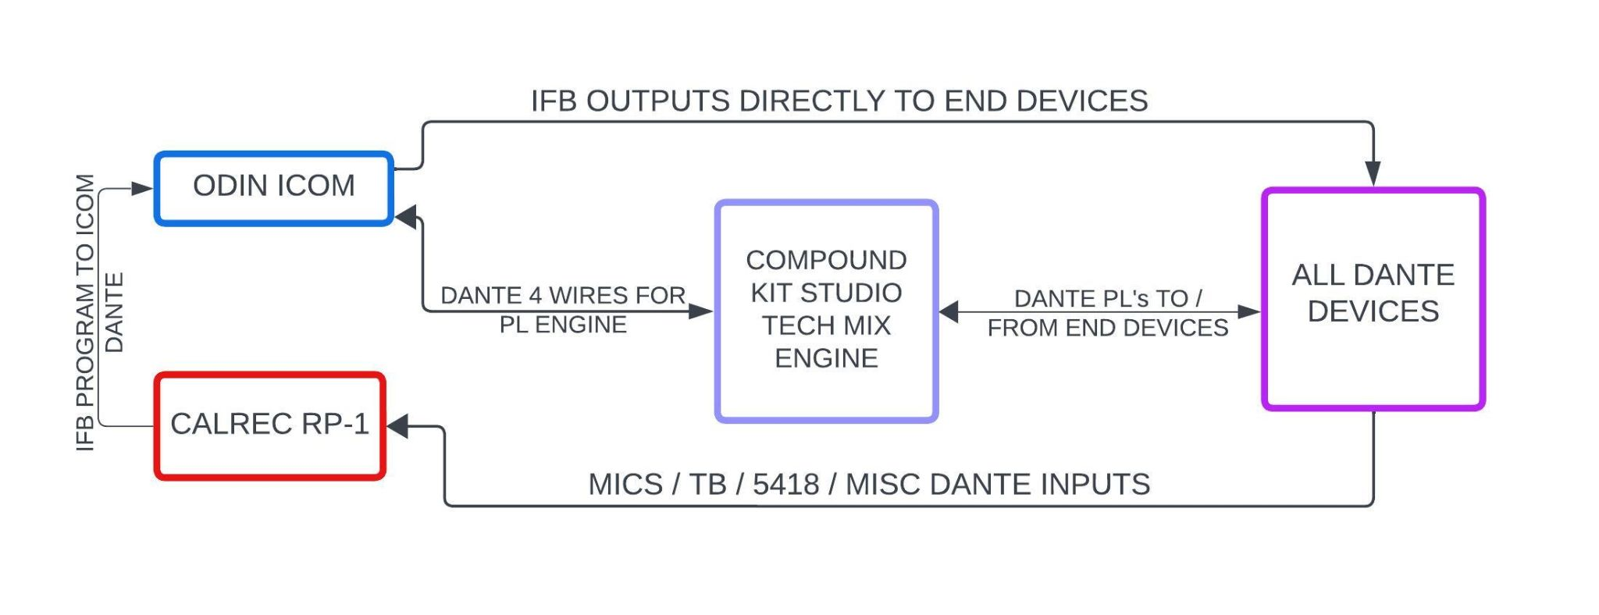

The clocking and synchronization in this model varies slightly from the mobile unit connection model. The RP-1 should be the primary clock leader in Dante Controller and the clock on the Ferrofish should be set to Dante. The RP-1 has a Vid1 coax input which will need to be supplied a Black Burst signal from the TOC kit, this will then keep all signals in sync with the video signals in the TOC.

There are MADI cards in slot D and E of the RP-1 to provide host feed audio splits into the RP-1 console as well the outputs to transmission. Each MADI card should be connected to the TOC router using fiber connections on the RP-1 patch panel. Please be sure to patch both the inputs and the outputs of each card as all available signals need to be available on an as needed basis.

Connection to the RP-1 GUI can be made by navigating to the specified LAN1 address on the Compound PC in a Google Chrome Web browser. When troubleshooting a connection can be made to the RP-1 locally by plugging into LAN3 on the front of the RP-1 unit - IP address 192.168.1.1 SN: 255.255.255.0

All RP-1 units have shipped with a baseline expected programming completed on them so if the audio workbook for each event is followed there will be a very good starting point in place on which to execute the production needs. Outputs to transmission have been mapped accordingly on the MADI cards - **PLEASE NEVER UNPATCH ANY SIGNALS BEING SENT TO THE MADI CARDS WHEN TESTING SIGNALS** - all signal and continuity testing should be completed by temporarily setting input channels to TONE on the RP-1 - if a signal cannot be tested this way, refer to the guidance of the shows A1 if this signal needs to be tested by anyone apart from the A1 mixing the show.

COMPOUND KIT DETAILS

The COMPOUND KIT contains the following devices and patch panels

* FERROFISH A32 DANTE
* STUDIO TECHNOLOGIES 5422 MIX ENGINE
* COMPOUND PC
* 24 PORT PRIMARY SWITCH
* 12 PORT SECONDARY SWITCH
* SESCOM ANALOG OVER FIBER CONVERTER 4 XLR F 4 XLR M
* 32X32 XLR IO FOR ANALOG FERROFISH INTEGRATION
* FIBER PATCH PANEL FOR SWITCH UPLINK PORTS TO OTHER KITS

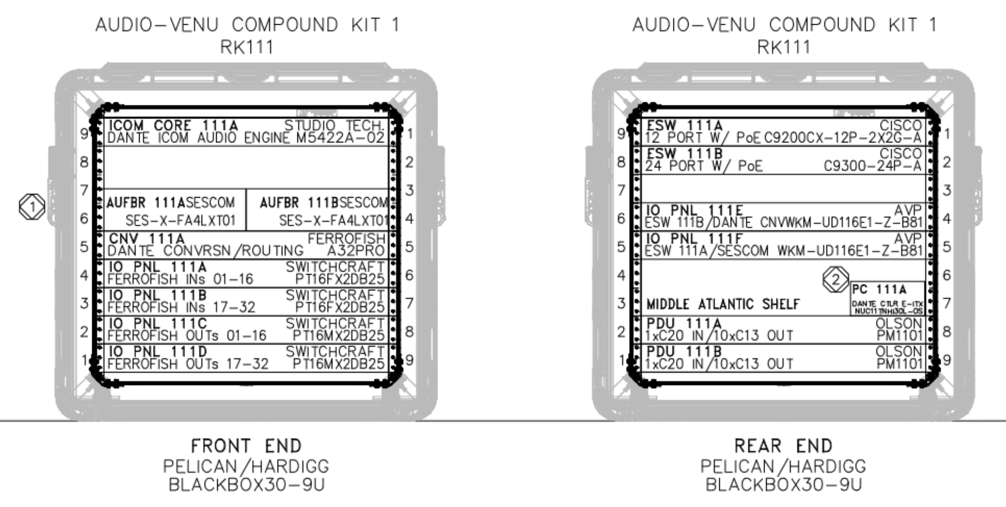

POWER

The COMPOUND KIT has A and B CEE16 PLUG connectors to supply redundant power to the A and B PDUs. The Compound PC and associated monitor run on A power only. The Secondary Switch runs on B power only. The Sescom and Comrex units also remain single threaded for power on B power. All other devices are redundantly supplied with A and B power. Please ensure that your A power CEE16 is fed from the OBS Tech Power distribution in the TOC and your B power CEE16 is fed from the NBC supplied 6K UPS in the TOC

CONNECTIONS AND GEAR OVERVIEWS

Fiber connections to BOOTH KIT and AUDIO KITS need to be made using ST-ST fiber runs, refer to the NETWORK FIBER CONNECTIVITY section above for a more in depth look at best practices. Primary Switches can only be connected to other Primary Switches and Secondary Switches can only be connected to other Secondary Switches. DO NOT CROSS THE STREAMS. In addition the Sescom analog over fiber units have ST-ST fiber connections that need to be made to the BOOTH KIT. The MADI fiber connections must be made if integrating with a mobile unit, best practice is to hook up one RX and both TX ports. All fiber connection ports live on the fiber break-out panel on the rear of the COMPOUND KIT.

There is an ADMIN ethernet port on the rear of the COMPOUND KIT, NBC venue B-LAN Data must be plugged into this port so the compound PC can be made available for remote access. This is the route the RP-1 access GUI will take when it is being used with the Audio System. The PC also has a monitor, keyboard and mouse sent along in a case for local access and connection to the PC - the monitor cable and power are loose in the COMPOUND KIT and the mouse and keyboard can be plugged in directly to the open USB ports on the front of the PC. The username for the compound PC is Audio2024 and the password is Pass12word -This PC will be used to access Dante Controller, ST Controller, Remote Fish, RP-1 GUI, Lance ADX system. Dante and Ferrofish presets will be saved on the compound pc for recall as necessary.

If any of the PC GUI’s do not load on initial start-up please check the USB/miniUSB connections at the rear of the PC by removing/unscrewing the PC tray and re-stabbing the connections

There are two Sescom analog over fiber units to pass back-up audio between the Booth and the compound on a completely independent path outside of the Dante Network. The 4x male XLR ports on the Sescom unit are incoming audio from the booth of either individual microphones for discreet mixing by the A1 or a microphone ‘scratch mix’ created in the booth.

The 4x female XLR ports on the Sescom unit are intended to feed an analog IFB from the compound up to the booth outside of the Dante network. This feed can be routed as necessary but is designed to flow into a rack unit mixer (Ch8) and then to a headphone amp where headsets can be moved to in a failure scenario. (The back up set up options in the booth will be detailed later in this document).

RP-1 connections are available and there are two marked ethernet cables plugged into the correct switches which need to be landed into the primary and secondary port in the RP-1 Dante Card which is in the C slot on the rear of the unit. In addition, the RP-1 needs redundant power cables which are cabled to the A and B power in the kit. Sync for the VID1 input and MADI connections to and from each of the cards in the D and E slots will be provided by TOC. Similar to the Admin network connection listed in the PC section, the Sync and Madi signals are not native to the Audio System and will need to be cabled from the TOC.The intention at this time is the Audio system will live side by side with the video systems in the TOC.

When the flypack / RP-1 integration is being set up, the Odin Intercom Primary and Secondary OMNEO ports need to connect to the Primary and Secondary switches respectively. In addition, OMNEO key panels can be deployed as needed off the Audio Systems Primary Switches. Control of the intercom will still remain on the venue engineering Laptops in the TOC.

There are 32 female and 32 Male XLR ports on switchcraft patchbays on the front on the COMPOUND KIT which are the analog input and output ports of the Ferrofish unit. While currently not in any intended designs these connections can be made as needed as use cases are requested by production.

The Ferrofish unit is set up to be a bi directional MADI <> DANTE converter so the MADI signals being received by the unit will be directly converted to the Ferrofish Dante transmitters in Dante Controller. The inverse statement is also true and all the Ferrofish Dante RX ports are directly converted to the MADI input signals on the attached mobile unit. When using the Ferrofish converter the clock of the unit should be set to the incoming MADI stream this way it is utilizing the clock generation of the mobile unit. This can be set or checked on the Ferrofish front panel or in the RemoteFish GUI. In Dante Controller the Ferrofish must be set as the preferred clock leader and the sync to external option must be checked. These clocking options can be found in the clock status menu of Dante Controller. All other basic routing and configuration of the Ferrofish unit has been set and pre configured on set up, so end users shouldn’t have to do much besides check settings and make routes to and from the Ferrofish in Dante Controller.

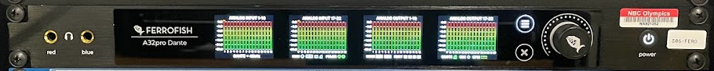

The Studio Technologies 5422A Mix Engine is a device that creates digital 4 wires connected to the intercom and then the Mix Engine drives the PL devices. If we didn’t use this device every channel on a Model 374 beltpack would use an intercom port which would be very inefficient as more PLs are deployed. The Mix Engine can be configured in many different ways but the default set-up we are using is 8 separate 8 channel PLs. This setup allows the creation of 8 separate groups/PLs (think CAMS, STGE, STAT etc…) where there can be 8 different devices attached to each created group/PL. One item to be aware of is that each group/PL on the mix engine needs to be attached to and from the intercom so there are only 7 other devices attached to any group. Best practice is to use channel 8 of each group to create the dante 4 wire back to the intercom. Each group/PL created on the mix engine will show up in Dante Controller with 8 transmitter channels and 8 receiver channels - to create the Dante 4 wire back to the intercom choose the relevant OMNEO port transmitter and route it to channel 8 of the relevant group / PL on the Mix Engine. The inverse of this process must be done to route the Mix Engine back to the intercom - in Dante Controller locate channel 8 of the desired Mix Engine group/PL and complete the route to the relevant OMNEO port receiver - this processes is then repeated until there are 8 Dante 4 wires attached to 8 OMNEO ports. The other 7 remaining channels on each group/PL can then be routed to and from specific channels on the Model 374 belt packs. This process is already completed on all Audio Systems being deployed for the MILAN CORTINA 2024 games - details on each baseline set-up can be found in each venue’s audio workbook. If adjustments need to be made to the naming or configuration of the groups/PLs on the mix engine - open the ST controller app and locate the 5422 device, once double clicked this will open a sub menu where a WWW icon can

be found in the upper left of the window - click this ICON to be brought to the web configuration GUI. It is strongly recommended that the 8, 8 channels groups/PL set up is left in place but names can be changed as needed. Be aware changing names in this menu will break current Dante routes. Change and add assignments as needed on top of the baseline configuration. Another item of note is that the Mix Engine is being used to distribute programs from the RP-1 on group/PL 8 in that integration model. To accomplish this a Dante route from the RP-1 carrying a local program mix is routed to channel 8 of the last group/PL (named PROGRAM) then the first 7 channels are used to distribute out to the receiving end unit Dante devices. In this setup no transmit route is needed back to the RP-1 as the audio traffic is only flowing in a single direction.

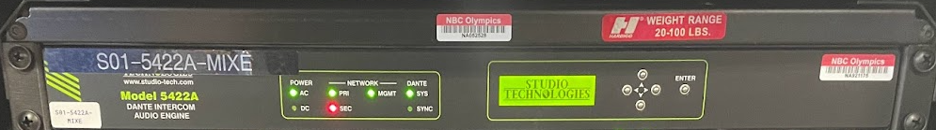

BOOTH KIT DETAILS

The BOOTH KIT contains the following devices and patch panels

* 24 PORT PRIMARY SWITCH
* 24 PORT SECONDARY SWITCH
* STUDIO TECHNOLOGIES MIC/LINE IN - LINE OUT XLR TO DANTE
* PATCH PANEL FOR FIBER CONNECTIVITY BACK TO COMPOUND KIT
* SESCOM ANALOG XLR OVER FIBER UNITS FOR CONNECTIVITY BACK TO THE COMPOUND KIT
* COMREX SYSTEM
* 1RU ANALOG MIXER
* 1RU HEADPHONE AMPLIFIER
* UPS

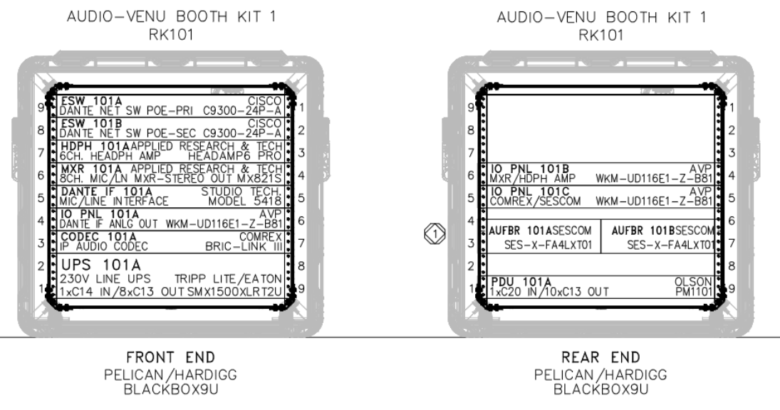

POWER

The BOOTH KIT has A and B CEE16 PLUG connectors to supply redundant power to the A PDU and the UPS. All devices in the booth kit are either redundant power devices or connected to the UPS which has a 25 minute run time under load. If power is lost an alarm will sound on the UPS to signal the need for resolution of a power outage.

CONNECTIONS AND GEAR OVERVIEWS

Fiber connections between the BOOTH KIT and COMPOUND KIT need to be made using ST-ST fiber connections on the 101C IO panel on the rear of the BOOTH KIT. There should be 6 strands run to the BOOTH KIT from the COMPOUND KIT.

* 2 strands for the primary switch from the COMPOUND KIT primary switch (only land one of these strands into the labeled ports, the other is a spare)
* 2 strands for the secondary switch from the COMPOUND KIT secondary switch (only land one of these strands into the labeled ports, the other is a spare)
* 2 strands for the SESCOM one strand carrying audio to the booth and one strand carrying audio from the booth over the analog over fiber back-up units.

In addition to the fiber there is an ethernet port labeled UPS which needs Venue Data LAN from a NBC supplied IT switch in the booth. This cabling is not internal to the booth kit and will be sourced from the NBC IT kit.

RAW PUBLIC INTERNET is also required at all venues for the COMREX backup device - this is a specific drop ordered at all venues and needs to be plugged in to the port shown below circled in GREEN.

Locating this MILAN CORTINA2024 Ethernet cable is imperative as the backup system relies on this 20mb cable drop.

This connection will have a static IP address which needs to be entered into the Comrex configuration page (details to follow)



In venue’s with expanded needs in the booth there is a jumper cable from the Primary switch to the secondary switch where we have made ports 13-24 part of the Primary network. All switches are labeled in appropriate colored tape but be aware this jumper needs to be put in place to allow Primary devices to be plugged into the secondary switch. If the jumper is not in place all ports on the secondary switch remain part of the secondary network. The jumper pictured in yellow below is in place in all venues believed to need expanded primary inputs at the booth location- Primary ports in this setup outlined in blue and secondary ports are outlined in red.

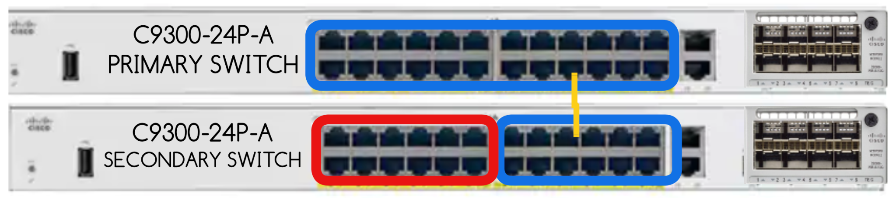

The Studio Tech Model 5418 is a Mic/Line Input and Line Output Dante <> XLR device. XLR inputs can go straight into the front face of the unit and the outputs come to patch on IO panel 101A on the front of the BOOTH KIT. Most functions (+48v, gain adjust, HPF) can be adjusted from the front panel of the device as needed but these and more in depth control can also be accessed using the ST controller application on the compound PC. These units are being used in the booth to provide effects microphones and other last minute requests by production. In the booth there is no currently planned use for the XLR outputs of these devices - in most situations a few if not all the ports are routed from the Ferrofish or RP-1 in Dante Controller so signals simply need to be patched to complete the signal flow as needed.

Each booth kit is supplied with a baseline number of end devices which has been expanded on an as needed basis at each venue to align with production needs. Information on the expected amount of equipment at each venue is detailed in each venue’s audio workbook. The baseline number of Dante end devices for the both is

4x- Studio Technologies 234 Announcer Consoles

4x- Studio Technologies 381 Mic/IFB Units.

4x- Studio Technologies 374 PL Beltpacks

**Studio Technologies 234** Announce Consoles are being used for the MILAN CORTINA 2024 Games at all announce positions. There are custom cable harnesses built to work with these devices that help take advantage of the back up connectivity in the Audio Systems. Each harness includes 2 Cat5e cables (color coded for primary and secondary switch connections), 1 XLR cable, 1 ¼ inch headphone extension cable. There are two network interface ports on the 234 units Primary and Secondary circled in the image below in the appropriate color coding

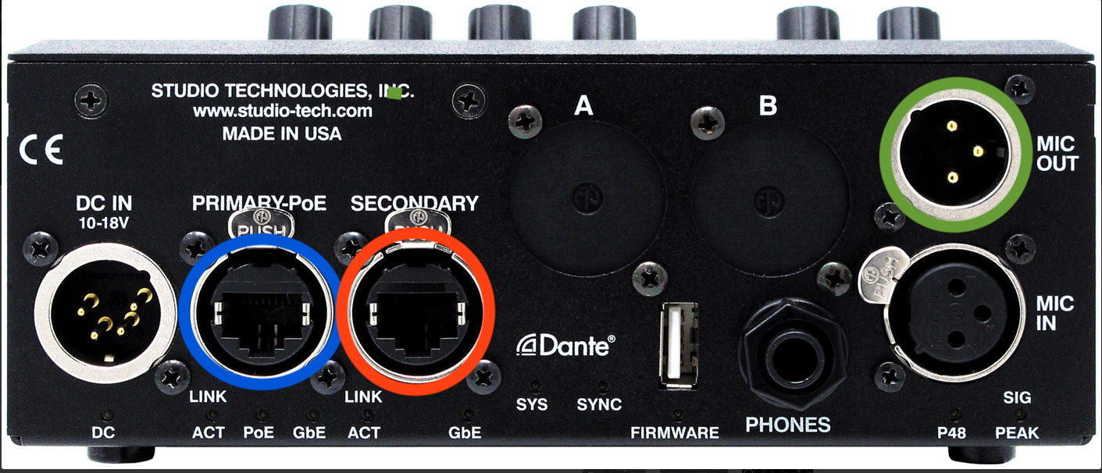

Use the custom harnesses to connect the Primary port to the Primary switch and the Secondary port to the Secondary Switch - the XLR should connect to the MIC OUT circled above in **GREEN** and should be connected to the 1RU mixer inputs on the back rear of the BOOTH KIT. This XLR output is a passive microphone output that allows for signal from the microphone input to continue to flow even if the device if the Dante Network has failed or the unit has lost power. Although the device can be powered over PoE on the Primary NIC it is best practice to also plug in the DC power supply that is shipped in with each kit. The headset XLR and ¼” headphone connector can then be plugged in as normal to the MIC IN and PHONES sockets. The ¼’ inch headphone adapter should be plugged in to one of the headphone amp outputs on the front of the BOOTH KIT rack, the headphone adapter connector on the other side of the harness should sit beside the announcer console and in a failure scenario the PHONES connector on the announcer console would be unplugged and the headphone connector should be plugged into the back up connector laying next to the 234 unit.

For incoming sources to the console this unit provides a MIC out and 4 TB outputs in Dante Controller - in the basic configuration and planned use with the Audio Systems most venues only have the MIC OUT and 2 of the 4 TBs in their planned use. For IFB return to the device, the Model 234 unit has 2 MAIN listen knobs and 4 TB listen knobs that act as sources to the talent’s headphones, MAIN 1 and 2 are stereo sources with a left and right ear destination in Dante Controller the 4 TB listen knobs are mono sources and left/right/both can be selected on the configuration screen in ST controller. In the basic planned configuration and present use cases, only MAIN 1 is in use as a stereo interrupt / non-interrupt IFB signal. Be aware that on the front of the unit there are two push out knobs for SIDETONE and MASTER - the master volume must be up and is a relative balance with the MAIN 1 knob for level control. SIDETONE on the unit should be turned all the way down as the A1 should deliver a complete mix with integrated microphones out to the IFB signals. WIth **DC IN** power connected , the MIC OUT XLR and the headphone adapter on the back up harness in line, a Mic and IFB signal can still function to the compound or remotely to the Comrex device even if there is a complete primary and secondary network loss.

All M234 units must have the supplied DC Power adapter connected to the technical power infrastructure in the booth otherwise a loss of POE power will power off the M234.

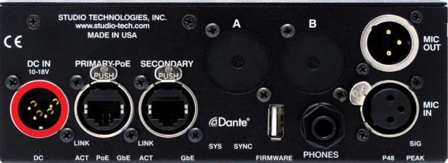

Management of all the model 234 announcer consoles is available through the ST controller application on the Compound PC- from the software - microphone gain along with behavior and function of the buttons can be configured. By default, all buttons are set to momentary. The potentiometer knobs can be configured to be pressed to MUTE the incoming channel - in the current configuration all the TB listen knobs can be muted by pressing each volume pot (an indicator light will turn purple to show mute). A blue indicator light verifies an unmuted channel, each device is configured to pulse green on the volume knobs in accordance with the reference level of the signal passing through that listen knob.

**Studio Technologies model 381** on-air beltpacks can be deployed on an as needed or requested basis if a stand up in or near the booth requires a handheld microphone with telex style in ear monitors. Basic audio inputs and outputs are part of this device with a single XLR microphone input and ¼’ headphone out is accessible on the bottom of the unit. These units have a single NIC that should be connected to any port on the Primary Switch using an ethercon cable. The cables provided are ethercon for the device end and raw Cat5 on the end intended to plug in to the switches. These devices only exist as part of the Primary Network infrastructure and are not intended to function in any disaster recovery scenario. On the top side of the device there are two LISTEN volume knobs - one one for each ear of a stereo in ear monitor. These knobs show up as discrete inputs on each device in Dante Controller and each unit also provides a MIC and Talkback output as available transmitting sources in Dante Controller. If a device has a planned use both the Mic and TB are already routed and configured as part of the base configuration at each venue. Management of the model 381 is available through the ST controller application on the Compound PC - where microphone gain and button functionality is available to configure.

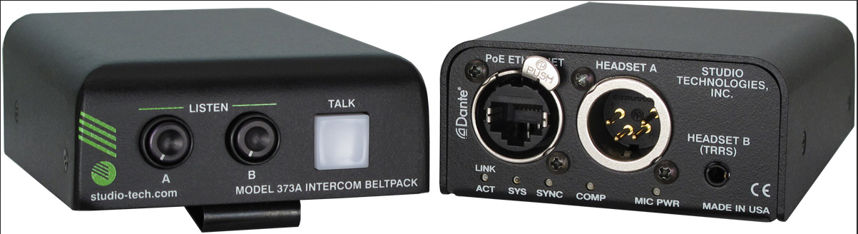

**Studio Technologies model 374** intercom belt packs are being used as part of the BOOTH KIT to provide party line communication in the booth location. These units have a single NIC and must be plugged into a Primary Switch port using a supplied ethercon connector. These units have a single 5 pin XLR headset with 4 talk buttons and 4 listen knobs on the top of the unit. The 374 units provide 4 discrete talk and listen positions which are available as transmitters and receivers in Dante Controller. The Studio Technologies Mix Engine is being used to drive the party lines on the 374 beltpacks; each button on each individual unit is routed to and from one of the 7 available channels of the 8 group/PLs in Dante Controller. Channel 8 of each group/PL in the Studio Technologies Mix Engine is routed back to the intercom channels either directly or through the Ferrofish as detailed above in the COMPOUND KIT details and MOBILE UNIT INTEGRATION. While the initial set up of these units is fairly in depth - the actual use of the devices is very simple - on a per channel basis each volume pot adjusts the level of the incoming party line and the button is a momentary push to talk on that party line. Management of the Studio Tech Model 374 devices is available on the ST controller application on the Compound PC - microphone game as well as functionality of the buttons and mapping between left and right ear of incoming sources are available to configure in this application. There is a baseline configuration that has been set and configured into the MIX ENGINE as well as the 374 beltpacks so they can operate quickly as plug and play on site. Please refer to each venue's audio workbook for details on the deployed configuration. 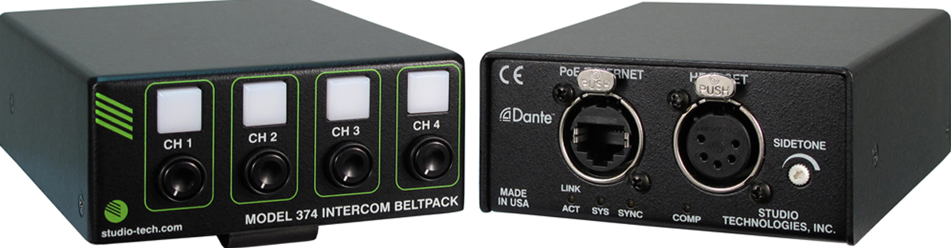

Please Update ST Controller to Version 4.01.00 (64-bit) from [here](https://studio-tech.com/stcontroller-application/) if not already done

The remaining devices in the booth KIT are responsible for providing back up and failsafe plans in case of problems with any planned primary solutions. As described above, each of the model 234 units has an XLR output connector that provides a discrete path to the input signal on the headset microphone. The XLR output will pass mic level output out full time - even if the box has no power, to bring this signal to a usable level it needs to be connected on the rear of the BOOTH KIT in the IO panel break out pictured below.

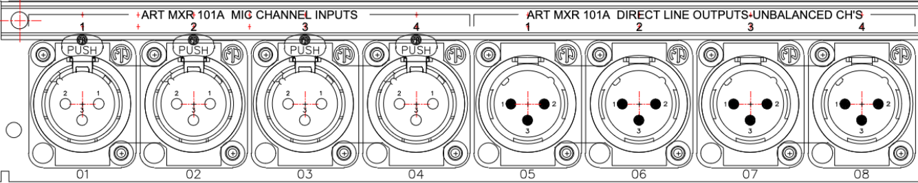

These 4 inputs are connected to the ART line level mixer which can be controlled on the front of the unit. These input levels should be set as directed by the productions A1 and must be panned HARD LEFT on channels 1-4 of the mixer. If working on mobile unit based production the direct line outputs shown in the image should be connected to the Sescom analog XLR input which will transport these protected signals to the Sescom analog XLR outputs in the COMPOUND KIT to provide an analog style back up of each announcer microphone directly to the mobile unit.



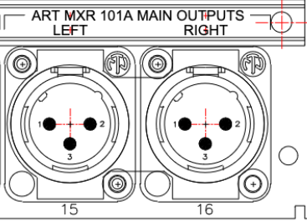

If working with an RP-1 as a remote production the 234 unit’s XLR outputs should still be connected to the 4 ART mixer inputs however, instead of using the discrete line outputs there is also a stereo left and right output of the mixer. The LEFT output of the mixer should be connected to the CODEC 101A COMREX LEFT INPUT. This connection then transports the output of the mixer over raw public internet back to a Comrex receiver in the Stamford facility where it can be integrated directly into the audio console mixing the production. As mentioned above RAW public internet will be ordered and available in the booth to be plugged into the port shown above on the rear of the BOOTH KIT.

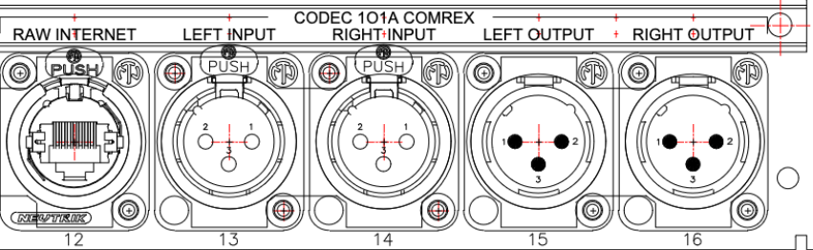

For back-up return audio, there are again two ways to facilitate those signals depending on where the production is being mixed. When the production is being mixed from a mobile unit a single IFB with a complete IFB program mix set as the input should be created on the intercom and sent analog to the Sescom XLR inputs in the COMPOUND KIT. This signal will be carried over the isolated fiber pairs to the BOOTH KIT where it needs to be patched into the RIGHT channel of the headphone amp’s XLR connectors on the rear of the kit.

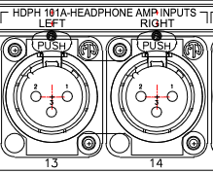

The ¼” connector on the custom harness should be plugged in on the front of the BOOTH KIT directly into the headphone amp itself. MONO R should be pressed and there will be individual level and balance controls on the first 4 channels. In case of any failure the headphone connector from the headset should be moved over to the open ¼” plug to facilitate the back up connectivity

This process remains almost identical when working with an RP-1 fly pack except that the source for the back up IFB will return back directly to the BOOTH KIT over the Comrex device - the LEFT CHANNEL output of the Comrex needs to be connected to mixer channel 8 input- The left and right outputs of the MIXER need to be connected to the left and right inputs of the headphone amp. On the front of the MIXER the first 4 channels can be panned to to center while channel 8 remains panned hard right. The rest of the connections can be completed as described above. MONO L and MONO R should be engaged -this will allow for the local mix to remain and back up interrupt and mix will flow to the headsets once the cable is moved over. 

The section above describes the cabling and scenarios for back up and failsafe audio in case of a complete failure of the Primary and Secondary Dante Networks, the following items are failure scenarios on and active solutions to safely resolve any issues. It is important to reiterate here…

**NEVER PLUG A PRIMARY NIC DEVICE INTO A SECONDARY NETWORK SWITCH PORT.**

If there are any connectivity issues troubleshoot fiber first. If possible, shine light and confirm strands and clean fiber connectors.

When in production, if fiber connectivity is unstable on either switch - there should be two strands of Fiber per switch that are both connected at the COMPOUND KIT – ONLY ONE OF THESE SHOULD BE TERMINATED AT ANY TIME ON THE BOOTH KIT - In case of failure- disconnect the main fiber from the suspect switch and connect the back up fiber. When moving to a new strand connect to the back up port on the IO panel that way we are connecting a fresh piece of fiber - new terminal connection - and new SFP slot in the switch. When changing fiber on the switch an expected loss of audio will occur for roughly 30 seconds while the switch renegotiates traffic over the new port connection. Be patient and wait for confirmation before retesting or confirming connection back on the network.

As long as either the Primary or Secondary Switch is active the announcer consoles will have no audio interruption. However, all of the single NIC’d 374 beltpacks are on the Primary switch so if audio is lost it will need to be resolved for full kit functionality to be restored.

The Analog back ups described above flow completely outside of the networked audio and completed outside of the Ferrofish / Madi / RP-1 facilities, so reverting to these signals will provide a failsafe and protected audio signal while the primary equipment can be brought back online. It is imperative that back up scenarios and back up audio signals are rehearsed and tested so audio personnel and equipment can work efficiently when problems are being resolved all while the on air audio is protected.

AUDIO KIT DETAILS

The AUDIO KITS contain the following devices and patch panels

* 12 PORT PRIMARY SWITCH
* STUDIO TECHNOLOGIES MIC/LINE IN - LINE OUT XLR TO DANTE
* PATCH PANEL FOR FIBER CONNECTIVITY BACK TO COMPOUND KIT
* DANTE PATCH PANEL FOR EASY CONNECTIONS INTO THE PRIMARY SWITCH
* UPS

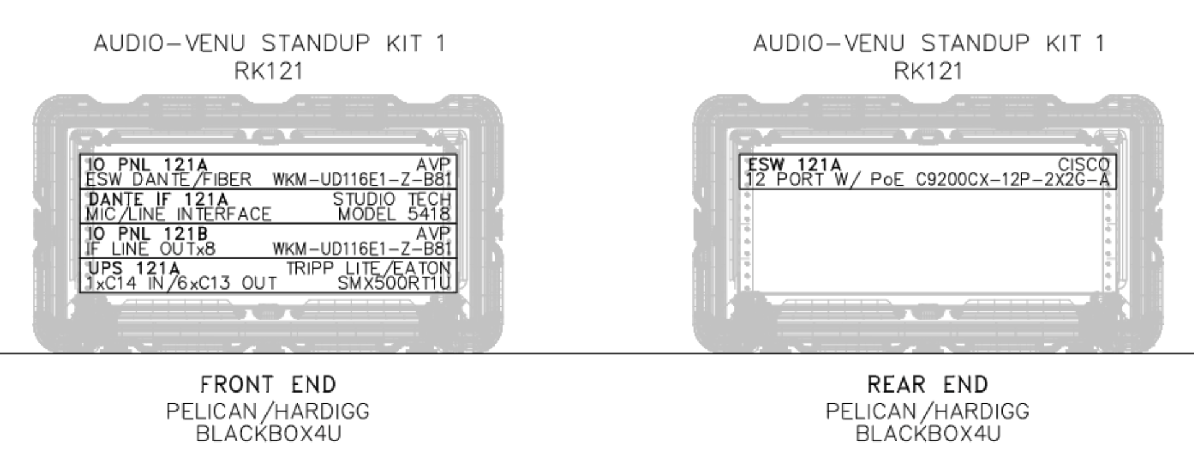

POWER

The AUDIO KITS have two CEE power connectors, one powering the UPS and the other powering the redundant power of the Studio Tech Model 5418.

CONNECTIONS AND GEAR OVERVIEWS

The Studio Tech Model 5418 is a Mic/Line Input and Line Output Dante <> XLR device. XLR inputs can go straight into the front face of the unit and the outputs come to patch on IO panel 121B on the front of the AUDIO KIT. Most

functions (+48v, gain adjust, HPF) can be adjusted from the front panel of the device as needed but these and more in depth control can also be accessed using the ST controller application on the compound PC. These units are being used in the booth to provide effects microphones and other last minute requests by production. At the Mixed Zone locations the first output port is being used to feed Friends and Family to the speaker and looped

through to the Polsen headphone amplifier- the remaining XLR outputs are routed from the Ferrofish or RP-1 in Dante Controller, so signals simply need to be patched on those devices to complete the signal flow as needed.

In addition to the 5418 XLR IO device, each Audio Kit has a designated deployment of 2-Studio Technologies model 381 units and 2-Studio Technologies model 374 units. By the system design, any Dante hardware can be plugged into any switch as long as primary ethernet ports only connect to PRIMARY SWITCHES and secondary ethernet ports on devices only connected to SECONDARY SWITCHES

There is a single 12 port PRIMARY SWITCH that breaks out to an IO panel on the front of the Audio Kits, this panel has 2 fiber uplink ports along with 8 cat5 ethernet switch into which all Dante devices can be connected. There are no SECONDARY SWITCHES in the AUDIO KITS.

In the exact same manner as the BOOTH KIT, 2 fibers should be run to the AUDIO KITS from the COMPOUND KITS a MAIN and a BACK UP fiber - BOTH strands may be connected on the COMPOUND END, but only the MAIN should be connected to the primary switch connected using the ST-ST connectors on IO panel. All CAT6 outputs have PoE enabled to drive the Studio Technologies devices.

**FRIENDS AND FAMILY INTEGRATION**

In most Mixed Zone locations there is a need to set up a ‘Friends and Family’ integration which consists of a speaker and/or headset which will be made available to athletes which will allow athletes to interact with friends and family members from home. A specific mix (-6db) should be generated from the mobile unit or RP-1 and sent a dante output which is routed to the first output of the 5418 unit in the Mixed Zone’s AUDIO KIT. This XLR output will then be patched to a supplied yamaha speaker to provide audio feedback for athletes unable to wear a set of headphones- to provide a headset option a POLSON personal headphone amp will be supplied and plugged into the loop out of the yamaha speaker to provide a headset if requested by production. In the planned set up the Mixed Zone reporter will always work the mic for the athlete during these friends and family integrations. The Polson headphone amp is ‘powered’ with 2x AAA batteries . The powered version cannot take line level -4db so the input must be -6db based on NBC testing otherwise the input will distort.

**TOC INTEGRATION**

When an audio system is deployed with a flypack and an RP-1 there is a slightly increased level of connectivity to and from the technical operations center that needs to be made.

SYNC- Blackburst will need to received and plugged into the video 1 input of the RP-1

INTERCOM OMNEO- a primary and secondary ethernet connection will need to be received from the venues intercom. PRIMARY OMNEO goes into the COMPOUND KIT’s PRIMARY SWITCH, and SECONDARY OMNEO goes into the COMPOUND KIT’s SECONDARY SWITCH.

DARK 88 - venue engineering and comms are using glensound Dark 88 units to convert Dante to Analog XLR which will be connected to and from the venue’s camera control units. While these units are dual NIC’d, only the primary of NIC of each device is set up and configured for use - so each units primary NIC will be need to be connected to the COMPOUND KIT’s PRIMARY SWITCH

The RP-1 already has two cables supplied in the COMPOUND KIT and connected to the appropriate switches - connected the BLUE tagged cable to the RP-1’s PRIMARY Dante and the RED tagged cable to the RP-1’s SECONDARY Dante port.

The RP-1 has two MADI cards which need to be connected to the TOC router, the current planned integration is through LC-LC fiber. The RP-1 has a breakout panel on the rear of the unit to make all the units connections - be aware of the dip switches that are on the physical MADI cards in the D and E slots of the RP-1 which change the expected MADI signal from BNC to SFP/FIBER. While the RP-1 will transmit MADI on both the fiber and coax outputs at the same time, audio will only be received into the MADI cards on the source selected on the MADI cards.

NBC VENUE DATA LAN will need to be connected to the LAN1 port of the RP-1 and another run of this same resource will also need to be run to the ADMIN connection port on the front of the COMPOUND KIT.

These connections drive RP-1 integration and provide remote access to the management PC in the COMPOUND KIT.

**AUDIO SYSTEMS NETWORKING DETAILS**

As laid out repeatedly in this document all the AUDIO SYSTEMS are based on protected fully redundant networks in which audio will flow glitchless in the event of a failure. In an effort to provide as many failsafes and as much redundancy as possible both the PRIMARY and the SECONDARY networks are fully isolated off-net switches with separate subnets and separate switches at all locations.

It is helpful to not think of these networks as separate across the 10 systems but as one large PRIMARY NETWORK and one large SECONDARY NETWORK that encompasses all 10 systems. There are roughly 475 devices across all 10 systems all of which have unique IP addresses and unique Dante names - the purpose of this scheme is so that any device or kit can work with any other device or kit without the worry of conflict of reconfiguration needed. Any device from any system can be plugged into a kit from any other system and it will show up on the network in Dante Controller and be available to be freely routed.

The PRIMARY network is a /23 with a subnet of 255.255.254.0 - the increased size of this subnet is to handle the large device count and can handle up to 510 unique devices. The addresses scheme for all primary devices is 192.168.100(or101).XXX where the XXX in the last octet is the unique address of the specific device.

The SECONDARY network is a /24 device with a subnet of 255.255.255.0 - we don’t need to increase the size of this subnet because there are significantly fewer devices with two network interface cards so we don’t need the added size of the /23 network.

There are available addresses that can be requested if any outside system devices need to be added to the network - KARL MALONE, MIKE DICRESCENZO, and GLENN STILWELL can provide addresses and approve adds the the Audio Systems - please contact them for available addresses before adding anything to the Dante Networks.

Furthermore, never attach a truck’s Dante Network to the isolated network of the Audio Systems - it is imperative that a DHCP server does not get connected to this network. Nothing but audio and comms devices should be utilizing the switches that are part of the Audio Systems.

In addition to the unique IP addressing scheme and more important to Dante is the unique naming structure that keeps every device ID’d independently across the 10 system network. Device names are printed in white with black text and stuck on to every device so it can quickly and easily be identified.

Each Device name starts with S0#- which identifies what system it belongs to by default.

The next portion of the name will identify the model of the device to quickly identify its resources and use case for example 234 / 381 / 374 etc…

The last portion of the Dante name will be what number of that model within that system a device is. This last portion of the name may also contain the location specific model for example if it is installed in the COMPOUND KIT, BOOTH KIT, or an AUDIO KIT.

Here as some examples of the system names

Studio Technologies Model 234 #3 in System 1 is named S01-234-04

Studio Technologies Model 5418 in AUDIO KIT 2 in System 3 is named S03-5418-AK2

Ferrofish A32 Dante Pro in System 5 is named S05-FERO

Studio Technologies Mix Engine in System 2 is named S02-MIXE

There are no repeated names across the network so devices can be easily identified and deployed by audio teams and routed as necessary. Any device can be used in any system and each device’s name identifier only implies its “home” system but can be used and deployed on any network. There is also a system called DPLY which stands for Deployable - this equipment does not belong to a system and is available for use as needed.

Each system has been deployed and shipped to each venue with the necessary resources that are known to be needed at the time of shipping. As production plans change please reach out to Karl Malone/Glenn Stillwell if more equipment is needed at a specific venue.

**MISC NOTES AND ITEMS**

Available at specific venues with Voice Over Booth needs Lance 120 ADX Dante announce consoles are available for use - the Lance Unit will run WITHOUT an ADX2400 controller. The Lance 120 can be connected directly to any PRIMARY SWITCH - DO NOT USE THE SECONDARY PORT ON THE LANCE. If needed, the Lance units come cased with “dumb” netgear switches which can be connected to the compound kit via the ST primary switch connectors. The Lance 120 can then be plugged into this dumb switch as needed. The Lance unit will be available on the Dante Network and can be routed as needed- if a VO booth is part of the plan - the inclusion of the VO booth is already planned in the default paperwork and routed in base configuration set up. When using the Lance the ADX software will need to be launched from the COMPOUND PC - this application needs to remain running when the 120 units are in use as it provides configuration and management access to the device.

At the venues with mobile units RTS Digital Belt Packs are available as needed if the 374 PL configuration needs to be added upon. The RTS Digital Belt Packs are **NOT** designed to work with the Audio Systems and can only be integrated from the intercom belonging to the mobile unit. Be advised, additional infrastructure will need to be deployed as the RTS digital beltpacks can not but plugged into the Audio Systems switches so another throw down switch from the mobile unit would need to be used at any location where an RTS DBP is needed.

If any of the PC GUI’s do not load on initial start-up please check the USB/miniUSB connections at the rear of the PC by removing/unscrewing the PC tray and re-stabbing the connections

If possible and whenever practical please recheck the IEC/C19/C20 power connections on all equipment after shipping to ensure solid connectivity

The Venue NUC can be logged into via RDP from any location on the NBC Network

The username for the compound PC is Audio2024 and the password is Pass12word

Search for RDP on the NBC provided laptop

Computer: Enter the IP address of the Venue NUC you are working with

User: tfayd\Audio2024

Password: Pass12word

Or in the Computer space indicate:

SPTGDANTENUC001

to

SPTGDANTENUC010 depending on the venue system you are working with

There are 10x NUC in venues 1 to 10

System #01 Opening Ceremony SPTGDANTENUC001

System #02 Figure Skating SPTGDANTENUC002

System #03 Hockey 1 SPTGDANTENUC003

System #04 Hokey 2 SPTGDANTENUC004

System #05 Speed Skating SPTGDANTENUC005

System #06 Alpine Women SPTGDANTENUC006

System #07 Alpine Men SPTGDANTENUC007

System #08 Sliding SPTGDANTENUC008

System #09 Snowpark SPTGDANTENUC009

System #10 Aerials & Moguls SPTGDANTENUC010

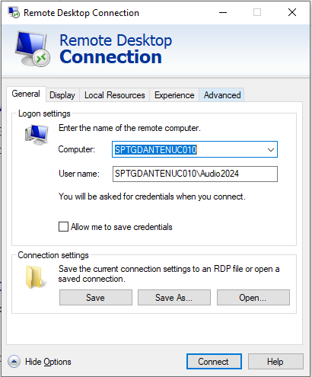

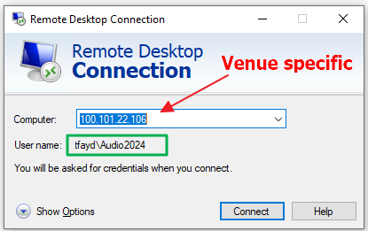

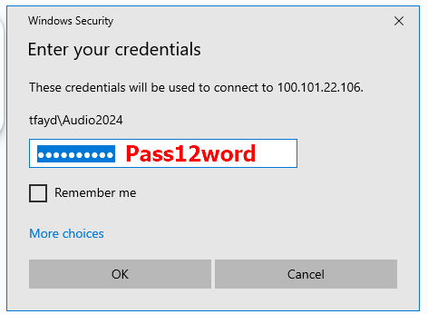

Venue Comrex Configuration example:

In your paperwork (and below) you will receive a committee static IP address for the Booth Raw internet for the Comrex

Example:

IP : 86.240.32.81

Mask : 255.255.255.248

GW : 86.240.32.86

You will need a laptop in the booth to connect to the Comrex

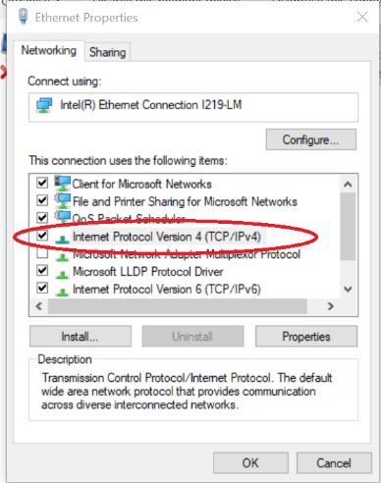

Ensure the laptop is on DHCP. If not…

Change it to DHCP in order to carry out the Comrex configuration below:

Comrex configuration

1. Install Comrex device manager on a PC/MAC. It can be downloaded here:<http://www.comrex.com/products/device-manager/>

a. Connect a network cable to Bric link III with the device manager software running and the Admin PC NIC set to DHCP.

b. Power up the Comrex, click scan for devices in the Comrex device manager software.

c. Connect to the Comrex, the password should be: comrex if not the secondary is C0m4ex12

If asked for User : NBC

2. Assign the Static IP address.

a. On the device tab, click network settings.

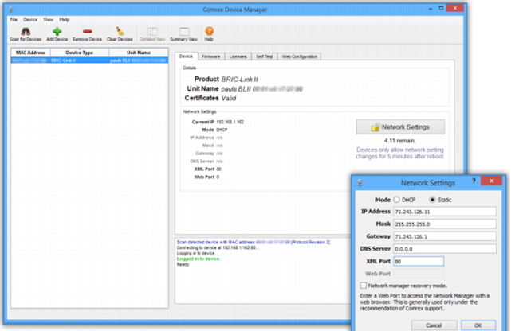

b. You have 5 minutes after power up to alter network settings, assign the provided addresses: ie: 86.240.**\*\*.\*\*** (use 8.8.8.8 for DNS)

c. Click OK, then power cycle the Comrex.

3. Connect to it as a static IP

Change your laptop NIC to an address in the range i.e. 86.240.32.50

a. Using a web browser navigate to the Comrex’s newly assigned static IP address. This will launch the interface page, login with the password above.

